EXPLANATORY NOTE
Within the scope of the Engineering Infrastructure Development Plan of the "Rail Baltica" Railway Line Kaunas - Lithuania-Latvia State Border Engineering Systems and Regional Stations, 7 regional stations are planned to be installed: Jonava passenger station; Jonava cargo station; Ručiūnai passenger station; Pasraučiai passenger station; Ramygala passenger station; Joniškėlis mixed station; Vaškai passenger (border) station:
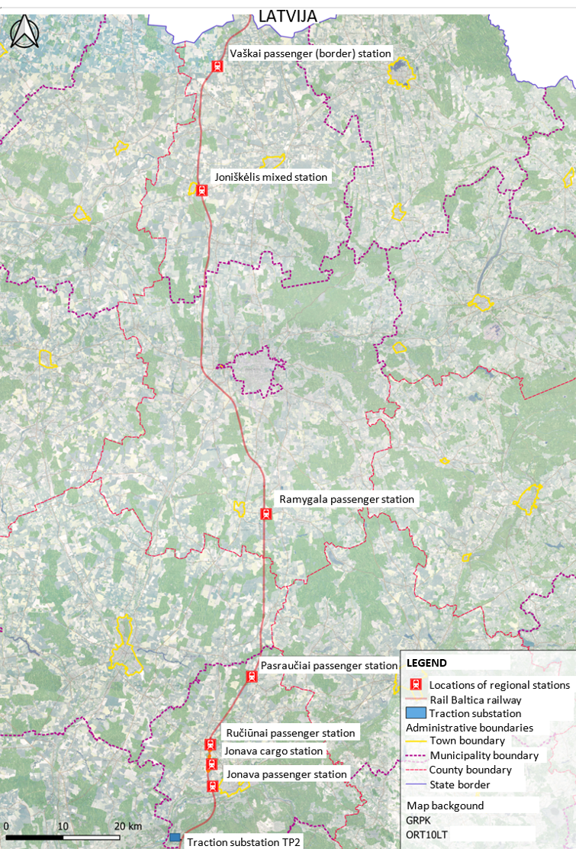

Regional passenger stations are intended for local passenger traffic and are focused on daily trips between regional stations located on the “Rail Baltica” railway line and international passenger stations.
The purpose of the development plan:
- To foresee the development of regional stations of the Kaunas - Lithuania-Latvia state border railway line of the "Rail Baltica" project.
- To foresee the electrification of the "Rail Baltica" railway line Kaunas – Lithuania-Latvia state border, as well as the development of railway transport traffic control, management and signaling systems and their devices.
- To foresee the territories necessary for the development of the engineering infrastructure of transport communications and create conditions for the harmonious development of this infrastructure.

The Vaškai passenger (border) station is closest to Latvia and situated 11 km from the border of the Republic of Latvia:
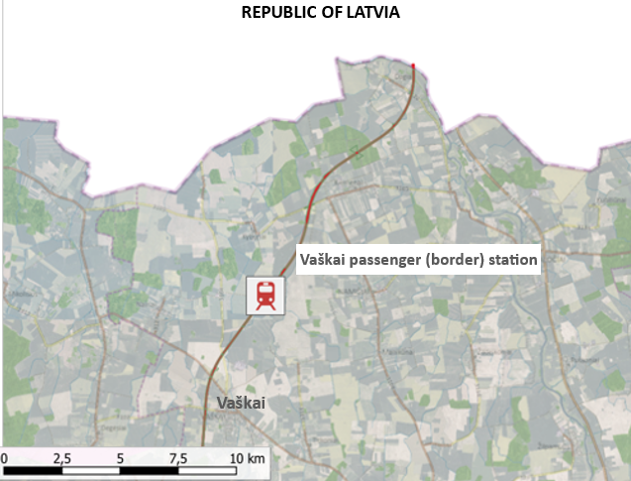

According to "Rail Baltica" railway Design Guidelines RB-DG-MAN (DG), type III for Vaškai passenger (border) station is planned:
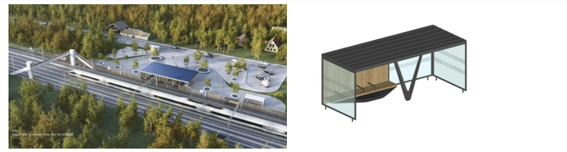

Strategic Environmental Assessment (SEA) performed for the planned economic activity. All required SEA components assessed. The possible impacts to the environment of Republic of Latvia could be related to trains acceleration or slowing down in station territory.
The impact is not significant due to:
- Electric trains will be used on the "Rail Baltica" railway line, air pollution is not foreseen.
- Acceleration or slowing down of trains causes changes in the noise generated by the trains. According to the provisions of DG, the deceleration distance of regional trains is about 900 m, which means that changes in the noise caused by trains in the territory of Republic of Latvia are not foreseen.

Based on the above arguments, we conclude that Engineering Infrastructure Development Plan of the "Rail Baltica" Railway Line Kaunas - Lithuania-Latvia State Border Engineering Systems and Regional Stations does not cause any consequences for the environment of the Republic of Latvia, cross-border consultations are not required.

